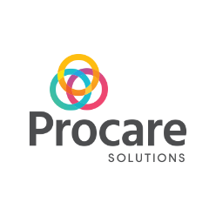
Northwoods Child Development Center uses the “ProCare Engage App” as a way to communicate with parents. Please visit our website enrollment page for the links for instructions on how to use and set-up your account now. https://www.northwoodschildcare.com/enrollment

Parent Name: ______________________________________________________________________

Child Name: ______________________________________DOB: ______________________

Email: ______________________________________________________________________

Cell Phone Number: _________________________________________________________________

Date: ______________________________________________________________________________

